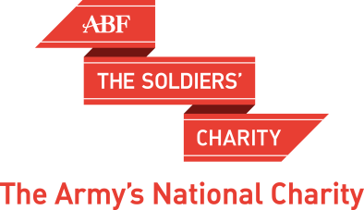

EXTERNAL GRANT
OUTCOMES REPORT

Name of Organisation:
Reporting Period:

In order to measure the outcomes not outputs resulting from the grants that ABF The Soldiers’ Charity award, we ask that all organisations who have been awarded a grant to provide an Outcomes Report every six months. This is to illustrate the impact that the funding has made to your organisation and the individuals that you support.

The information you provide should relate to the project outcomes and activities that were set out in your original application. Please complete the attached form as appropriate and attach to the report any relevant additional paperwork as deemed necessary to support your report.

Grant Details
Name of Project or Service that the grant supports.
Principal Contact
Name
Telephone No:
Email:
Project Duration: (if applicable)
Start date:
Estimated completion date:
Reporting period
From:
To:
Total Amount Awarded

Period for which grant has been awarded:
Total Amount Awarded
Charity/Organisation Update
Please provide any important information on your organisation which our charity should be aware off, for example:
Change in CE.
Status of organisation.
Major grants received from elsewhere.

Project Outcomes
- Was the grant spent within the grant period and to budget? If not, please give details of why not and how you have spent the Grant.
- Please briefly describe the main activities undertaken to implement the project or service.
- Please set out the planned outcomes for the project or service as outlined in your application. Have these have been achieved and if so in what way?
  - Have any of your planned outcomes not been achieved?
  - Why was this and has this changed how you work in any way? Are there beneficiaries for whom a positive outcome is still in progress?
- Please describe how you measured the difference that you made to beneficiaries’ lives?
Beneficiaries
- How many beneficiaries in total have directly benefited from the Project?
- How many beneficiaries have indirectly benefited from the Project from the Army family? This can include both the serving and veteran’s community.
- As per our Grant Terms and Conditions, please give details of a case study that highlights the outcomes you have achieved which could be used by our Charity. Please also provide an individual quote that illustrates this impact. Please confirm that we have permission to use this material both internally and externally.
Recognition
- How have you made beneficiaries aware of ABF The Soldiers’ Charity funding?
- How have you acknowledged the support of ABF The Soldiers’ Charity?

Declaration

The information provided on this form, and the attached supporting documents, are a true and accurate report of the Project activities and use of the funds provided to by ABF The Soldiers’ Charity. I confirm that ABF The Soldiers’ Charity has permission to use the case study and quote provided in this report within both internal and external marketing materials.

Signed……………………….. Date …………………

Position ……………………..

Organisation…………………

This question is in no means a way to ask for a return of funding or intended to be too interrogatory. It is purely a means for us to understand and learn what has worked and what hasn’t within the project, the reasons for this and what you may now do differently.
The case study and quote may be anonymous and do not need to include the individuals Capbadge but must be from the Army family. If you feel that it is appropriate and of benefit to your organisation and our Charity, a named case study or quote can be included at your discretion which we would then work together on to provide some wider media communication.

