THE ARMY CAROL SERVICE

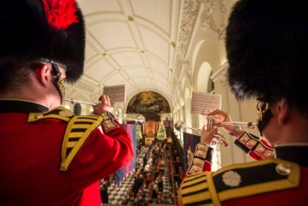

The Army Carol Service is a traditional service of lessons and carols hosted annually in the Chapel of the Royal Hospital Chelsea by ABF The Soldiers' Charity to benefit all members of the British Army. It is followed by a reception in the Great Hall.
The Chief of the General Staff will lead soldiers drawn from across the United Kingdom, representing the full range of ranks and diversity in today's Army, in reading the lessons.
We hope that you will be able to join the Army in supporting its National Charity.

Tuesday 12th December 2017 – 6.30pm for 7.00pm
Generously sponsored by Trailfinders

Early Bird Tickets (available until 30th September) £40
Tickets (from 1st October) £50

To make a reservation please telephone 020 3903 6030 or email ghogarth@soldierscharity.org
…………………………………………………………………………………………………………………………………………………………..
For tickets by post please send this form with a stamped addressed envelope to:
ABF The Soldiers’ Charity, London Regional Office, Wellington Barracks, London, SW1E 6HQ

1. Please send me …...…Early Bird Tickets at £40 each (available until 30th September)
Please send me …….. Tickets at £50 each (from 1st October)
Please send me …….. Child Tickets at £20 (age 16 and under)

2. I enclose a cheque for £………………. made payable to ABF The Soldiers’ Charity.

Name and address:…………………………………………………………………………………………………………

…………………………………………………………………………………………………………………………………….

3. I cannot attend, but enclose a donation to the charity of ………………………………………..

4. Boost your donation by 25p of Gift Aid for every £1 you donate.
In order to Gift Aid your donation you must tick this box:
I want to Gift Aid my donation and any donations I have made in the past 4 years to ABF The Soldiers’ Charity. I am a UK taxpayer and understand that if I pay less Income Tax and/or Capital Gains Tax than the amount of Gift Aid claimed on all my donations in that tax year it is my responsibility to pay any difference.

Signed:…………………………………………............................…. Date:………………….…………………..

Name (Printed):……………………………………………………………………………….……………………………

Email:………………………………………..…………..……….. Telephone:……………………………………….
If you would like to receive future information about our Autumn Lecture series, please tick this box □
If you would like to receive future information about other London events, please tick this box □

