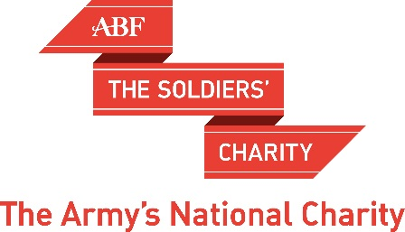
Cheltenham Cricket Festival
Lunch and Cricket
Mon 23 July 2018 - Ticket Application Form

For 2018 we are returning to the Cheltenham Cricket Festival. The date is Monday 23rd July, the first day of the Gloucestershire v Durham match. The format will differ from previous years in that we are taking tables at Cowshed Corner, a joint operation between the Campervin Co and Orchard Catering. The "Corner" is situated approx. mid-way between our previous marquee and the edge of the field and affords a good view of the game. We will have reserved tables of 8/10 (under cover) and exterior seating behind the boundary ropes, as we had in our own marquee in the past. A two-course lunch with choice of hot "Dish of the Day" or cold buffet and afternoon cake/tea/coffee is included and a well-stocked, reasonably priced bar is on site.

********************
For tickets please complete and return the form below:

Bristol/Gloucestershire/Wiltshire supporters:

Regional Director South West
ABF The Soldiers’ Charity
Building 750 Tel: 01980 672337
Picton Barracks
Bulford Camp
Wiltshire SP4 9NY e-mail: shollis@soldierscharity.org

Cheques payable to ABF The Soldiers’ Charity (please enclose an SAE)
or online to 20-00-00 Ac. 33922952 quoting reference: Your surnameCricketGlos

Oxfordshire supporters:
Contact Nick Leadbetter Tel: 01993 831571 or email at leadbetter184@btinternet.com Cheques made payable to ABF Oxfordshire.

********************************************************************************
I require ……………… tickets @ £40 each.

Name and address [In Blocks please]

……………………………………………………………………………………………………

.……………………………………………………………………………………………………

Post Code:…………………………..Tel……………………………..…….………..……………….

Email: .................................................................................................................................

